1. 測試內容：

測試 Flow 之 match field:“IPV4_SRC”,“IPV4_DST”是否正確運行。

1. 測試環境架構：

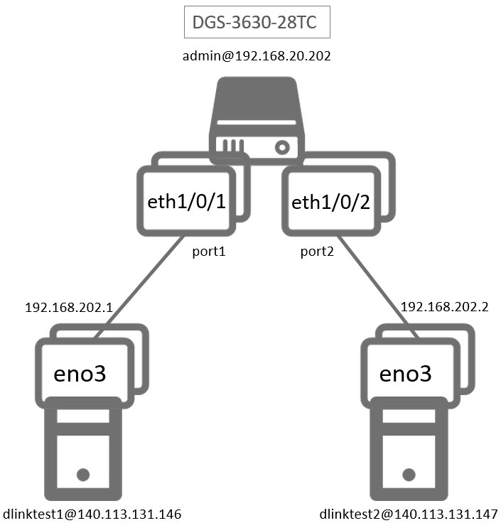

1. 測試環境組態：

* SDN controller: ONOS 1.15.0
* Switch: DGS-3630
* Hosts:
  + ubuntu 16.04.5 LTS
  + dlinktest1(實體機)
    - IP: 192.168.202.1
    - MAC: d0:94:66:5d:5e:08/64
    - Port: 1
  + dlinktest2(實體機)
    - IP: 192.168.202.2
    - MAC: d0:94:66:5c:45:20/64
    - Port: 2
* Apps:

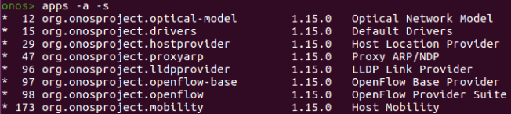

1. 使用之JSON文件：

* Flow Rule: (附檔：IPV4.json)
  + ETH_TYPE為必填欄位

|  |
| --- |
| {  "flows": [  {  "priority": 40000,  "timeout": 0,  "isPermanent": true,  "deviceId": "of:000078321bdf4000",  "treatment": {  "instructions": [  {  "type": "OUTPUT",  "port": "2"  }  ]  },  "selector": {  "criteria": [  {  "type": "ETH_TYPE",  "ethType": "0x0800"  },  {  "type": "IPV4_SRC",  "ip": "192.168.202.1/32"  },  {  "type": "IPV4_DST",  "ip": "192.168.202.2/32"  }  ]  }  },  {  "priority": 40000,  "timeout": 0,  "isPermanent": true,  "deviceId": "of:000078321bdf4000",  "treatment": {  "instructions": [  {  "type": "OUTPUT",  "port": "1"  }  ]  },  "selector": {  "criteria": [  {  "type": "ETH_TYPE",  "ethType": "0x0800"  },  {  "type": "IPV4_SRC",  "ip": "192.168.202.2/32"  },  {  "type": "IPV4_DST",  "ip": "192.168.202.1/32"  }  ]  }  }    ]  } |

1. 測試步驟：
2. ONOS GUI: Flow View



1. Monitor: Using ping tool

* Let h1 ping h2.

|  |
| --- |
| ping 192.168.202.2 –c 5 |

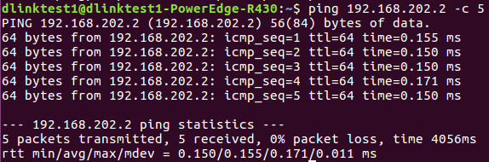

* h2 uses tcpdump to monitor.

|  |
| --- |
| sudo tcpdump –nni eno3 ip |

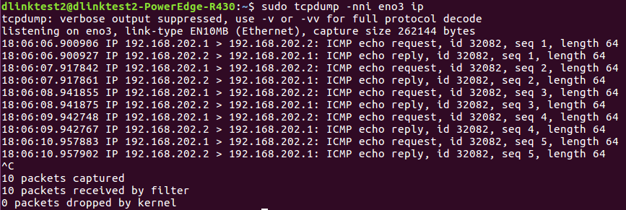

1. 測試結果：

Flow之match field:“IPV4_SRC”, “IPV4_DST”**可以正確運行**。